File 1 – VBS 2010 Item 2: Howdy Partners!

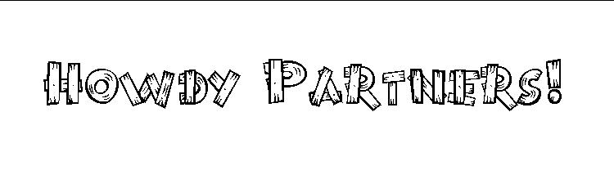
Welcome to LifeWay’s Saddle Ridge Ranch VBS 2010.
To put you in the ranch hand mood, look at the following western idiomatic phrases used by cowboys either on the range or around the ranch house. Can you decode their wild west lingo? Match the cowboy terms at the left with their modern translation on the right. Check your answers with a new friend.
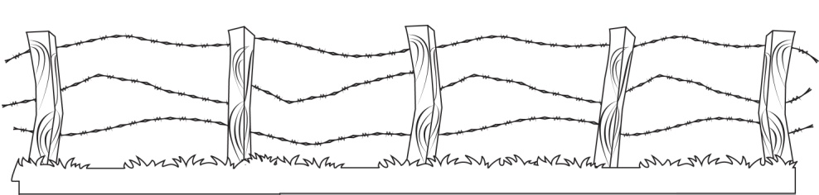
Tall Hog at the Trough |  | Tuff-up, get back on yer horse, don’t back down, don’t give up, and do the best you can with the hand you’re dealt.
Man at the Pot |  | Someone who is always alert and seldom or never caught off guard.
Barkin’ at a Knot |  | To experience a “spectacular event.”
Across Lots |  | A preacher.
See How the Cat Jumps |  | To discover the secrets or ideas of others.
Catch a Weasel Asleep |  | Do it or quit talking about it.
Cowboy Up |  | Superior, outstanding, exudes leadership.
Fish or Cut Bait |  | When a cowboy gets up to refill his cup from the coffee pot, if someone shouts this term, he is required to fill everyone’s cup.
See the Elephant |  | Doing something useless; wasting your time, trying something impossible.
Gospel Sharp |  | The fastest way possible, in the most expeditious manner.


